Report

Laboratory Work 9

Dmitry Ladutsko

July 28, 2022

# 1. Prerequisites

## 1.1. Passwords Index

|  |  |  |
| --- | --- | --- |
| Password Group | Login Name | Password |
| Operation System | root | “rootadmin” |
|  | oracle | “oracleadmin” |
|  |  |  |
| Oracle System | sys | “sysadmin” |
|  | system | “sysadmin” |
|  |  |  |
| Oracle Users | All DB users | “%PWD%” |
|  |  |  |
|  |  |  |

## 1.2. Folder Paths Index

|  |  |  |
| --- | --- | --- |
| Path Group | Path Description | Path |
| Operation System | Oracle RDBMS – BIN | /oracle/app/oracle |
|  | Oracle Inventory | /oracle/app/oraInventory |
|  | Oracle Database Storage | /oracle/oradata |
|  | Oracle Install Directory | /oracle/install |
| Oracle | ORACLE_BASE | /oracle/app/oracle |
|  | ORACLE_HOME | $ORACLE_BASE/product/11.2 |
|  |  |  |
| FTP | ftp Incoming Folder | **/ftp/incoming** |
|  |  |  |
|  |  |  |

# 2. Oracle Architecture - Partitioning

## 2.1. Task 01: CREATE Example of Range partitioning

**The Main Task** is to creating example of range partitioning table. Perform Administration tasks on all partitioning types:

| Maintenance Operation | Range Composite Range-* | Interval Composite Interval-* | Hash | List Composite List-* | Reference |
| --- | --- | --- | --- | --- | --- |
| [Adding Partitions](http://docs.oracle.com/cd/B28359_01/server.111/b32024/part_admin.htm#i1007318) | ADD PARTITION | ADD PARTITION | ADD PARTITION | ADD PARTITION | N/A[Foot 1](http://docs.oracle.com/cd/B28359_01/server.111/b32024/part_admin.htm" \l "BAJCBJBA) |
| [Coalescing Partitions](http://docs.oracle.com/cd/B28359_01/server.111/b32024/part_admin.htm#i1007442) | N/A | N/A | COALESCE PARTITION | N/A | N/A[Footref 1](http://docs.oracle.com/cd/B28359_01/server.111/b32024/part_admin.htm" \l "sthref213) |
| [Dropping Partitions](http://docs.oracle.com/cd/B28359_01/server.111/b32024/part_admin.htm#i1007479) | DROP PARTITION | DROP PARTITION | N/A | DROP PARTITION | N/A[Footref 1](http://docs.oracle.com/cd/B28359_01/server.111/b32024/part_admin.htm" \l "sthref214) |
| [Merging Partitions](http://docs.oracle.com/cd/B28359_01/server.111/b32024/part_admin.htm#i1007638) | MERGE PARTITIONS | MERGE PARTITIONS | N/A | MERGE PARTITIONS | N/A[Footref 1](http://docs.oracle.com/cd/B28359_01/server.111/b32024/part_admin.htm" \l "sthref215) |
| [Moving Partitions](http://docs.oracle.com/cd/B28359_01/server.111/b32024/part_admin.htm#i1007920) | MOVE PARTITION | MOVE PARTITION | MOVE PARTITION | MOVE PARTITION | MOVE PARTITION |
| [Splitting Partitions](http://docs.oracle.com/cd/B28359_01/server.111/b32024/part_admin.htm#i1008028) | SPLIT PARTITION | SPLIT PARTITION | N/A | SPLIT PARTITION | N/A[Footref 1](http://docs.oracle.com/cd/B28359_01/server.111/b32024/part_admin.htm" \l "sthref216) |
| [Truncating Partitions](http://docs.oracle.com/cd/B28359_01/server.111/b32024/part_admin.htm#i1008226) | TRUNCATE PARTITION | TRUNCATE PARTITION | TRUNCATE PARTITION | TRUNCATE PARTITION | TRUNCATE PARTITION |
|  |  |  |  |  |  |

**Task Results:**

Create document that will store all screenshot about **Maintenance Operations**;

Range Composite

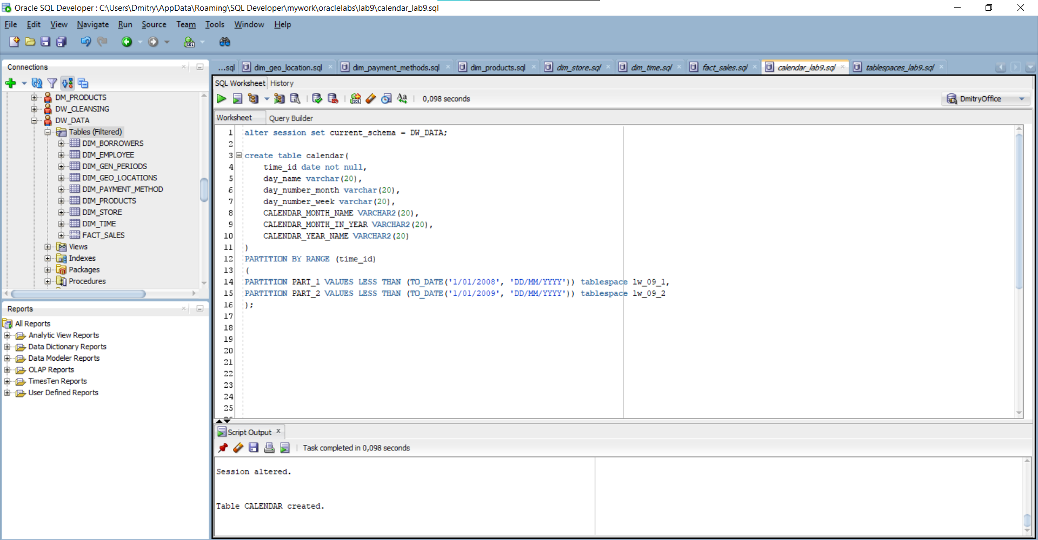

Picture 1 - Creating Partition

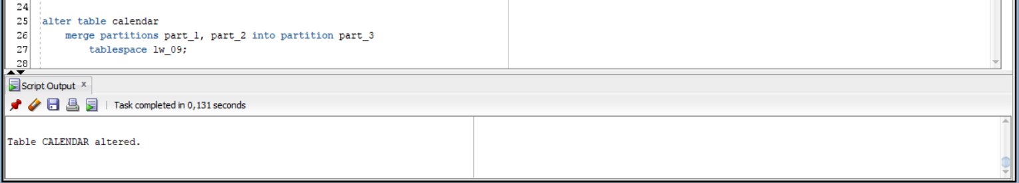

Picture 2 – Merging Partition

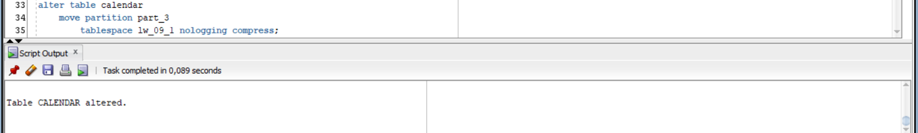

Picture 3 - Moving Partition

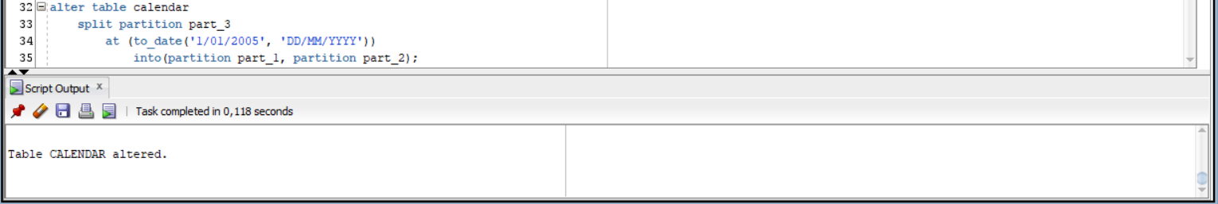

Picture 4 - Spliting Partition

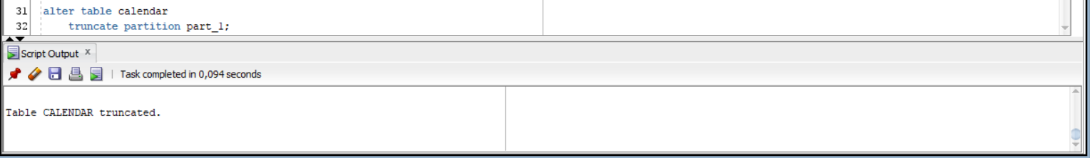

Picture 5 - Truncating Partition

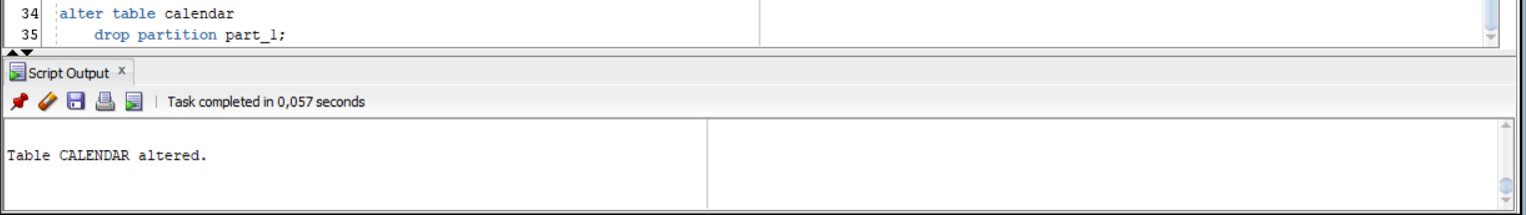

Picture 6 - Dropping Partition

Interval Composite Interval

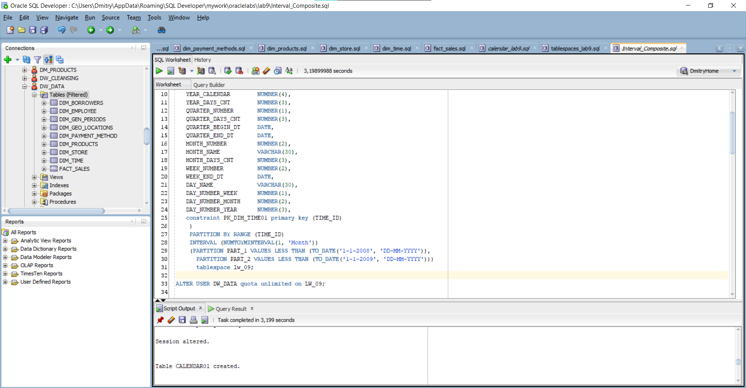

Picture 7 - Creating Partition

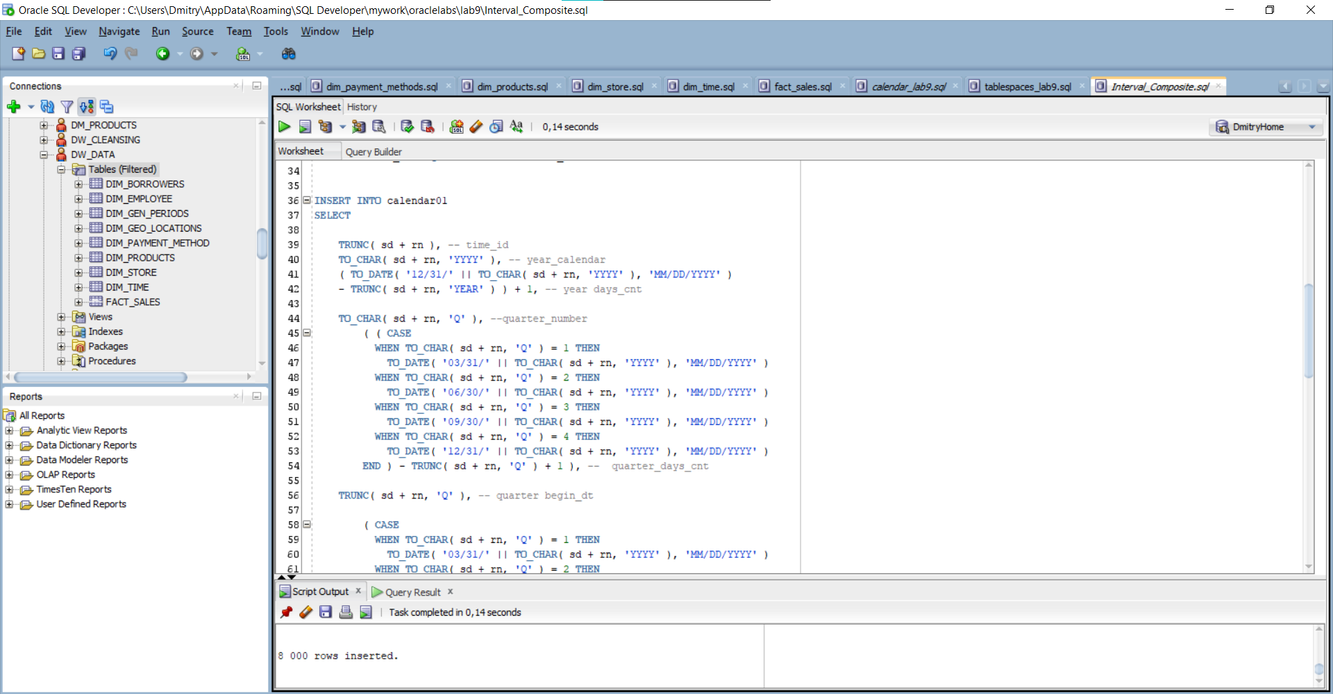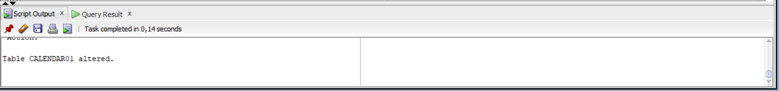

Picture 8 - Inserion and Merging

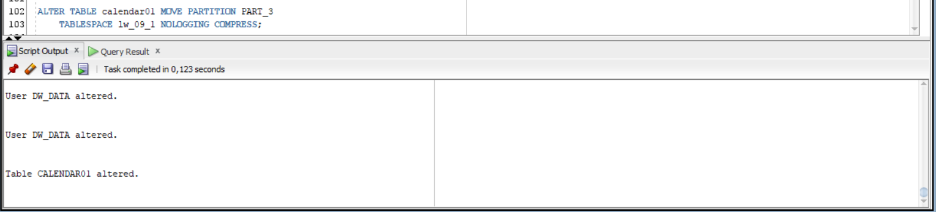

Picture 9 - Moving Partition

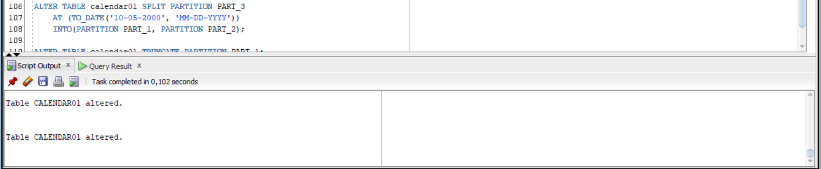

Picture 10 - Splitting Partition

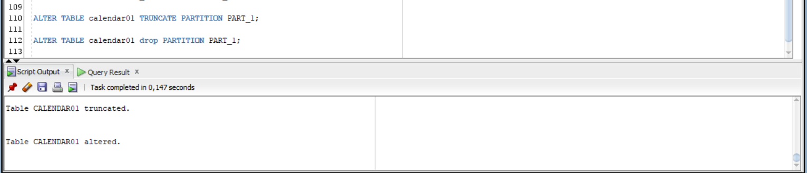

Picture 11 - Dropping And Truncating Partition

Hash

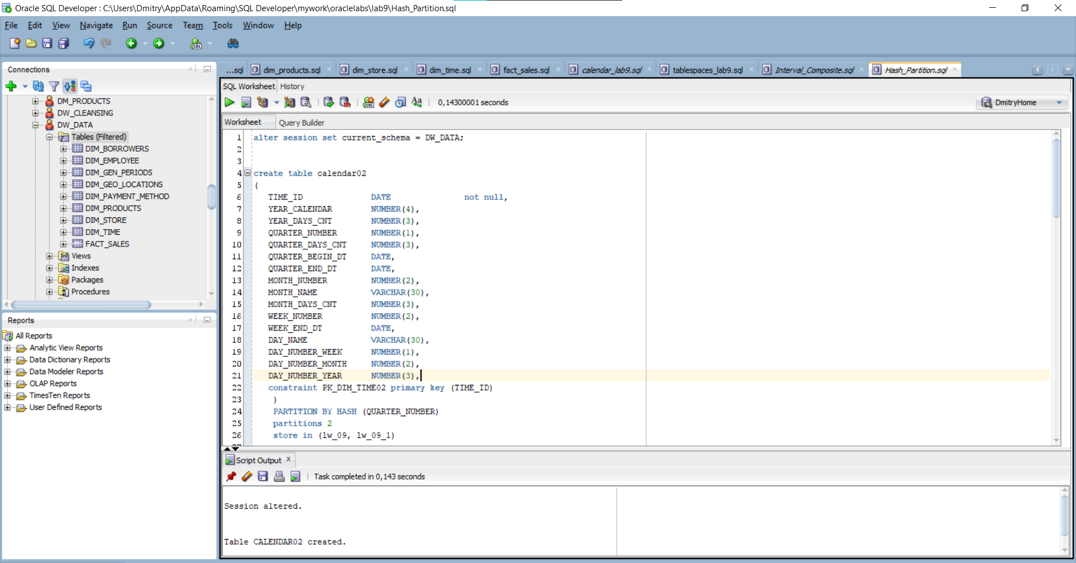

Picture 12 – Creating Partition

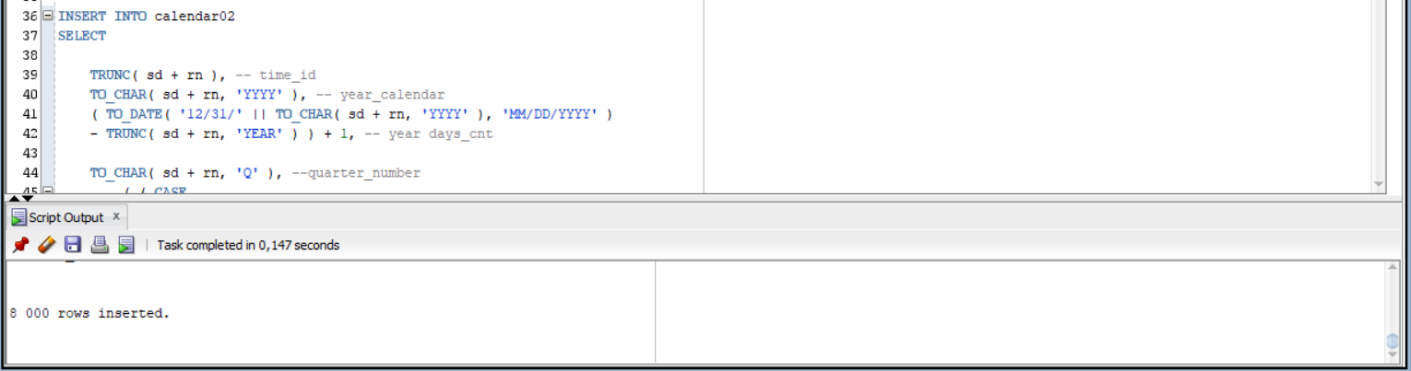

Picture 13 - Insering Table

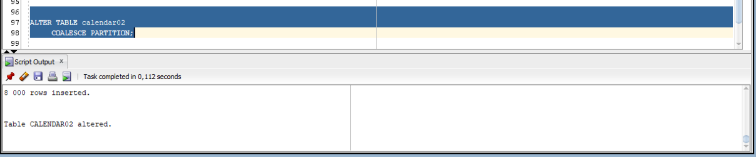

Picture 14 - Coalescing Partition

List Composite

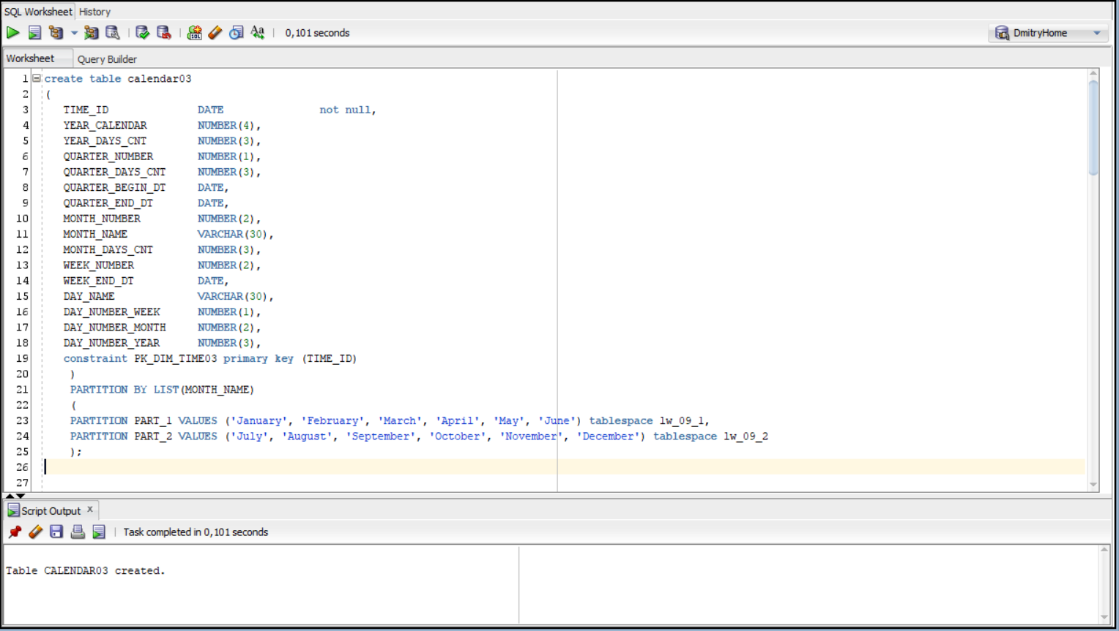

Picture 15 - Creating Partition

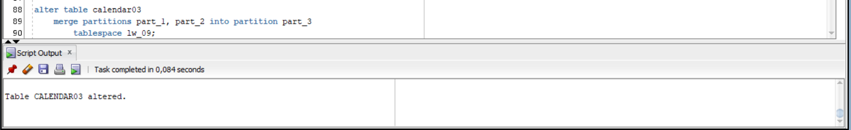

Picture 16 - Merging Partition

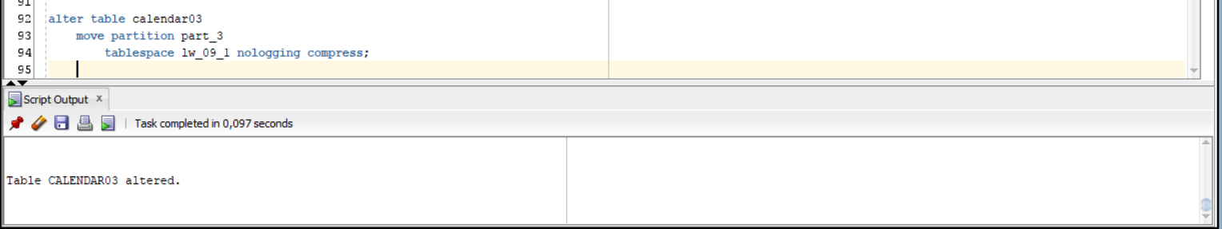

Picture 17 - Moving Partition

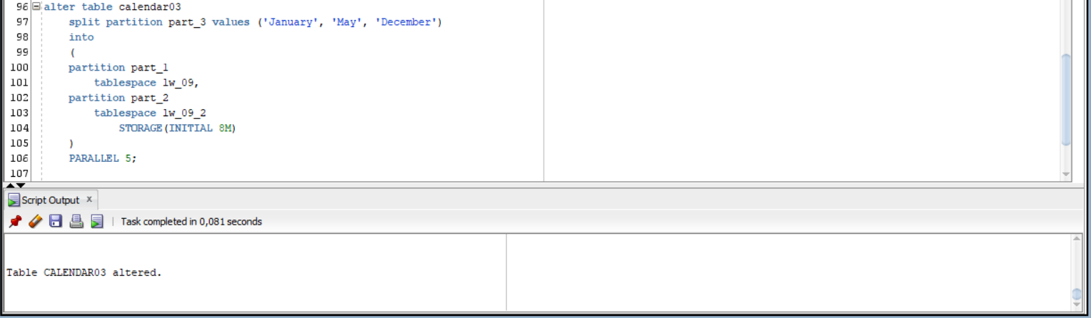

Picture 18 - Splitting Partition

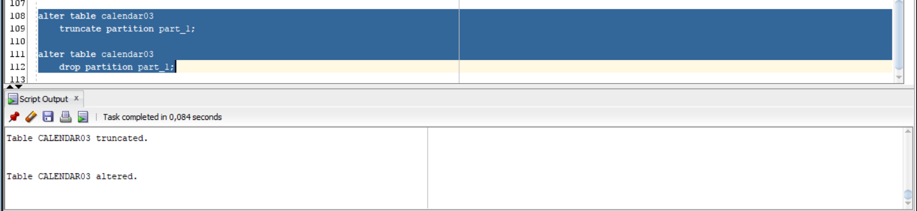

Picture 19 - Truncating and Dropping Partition

Reference

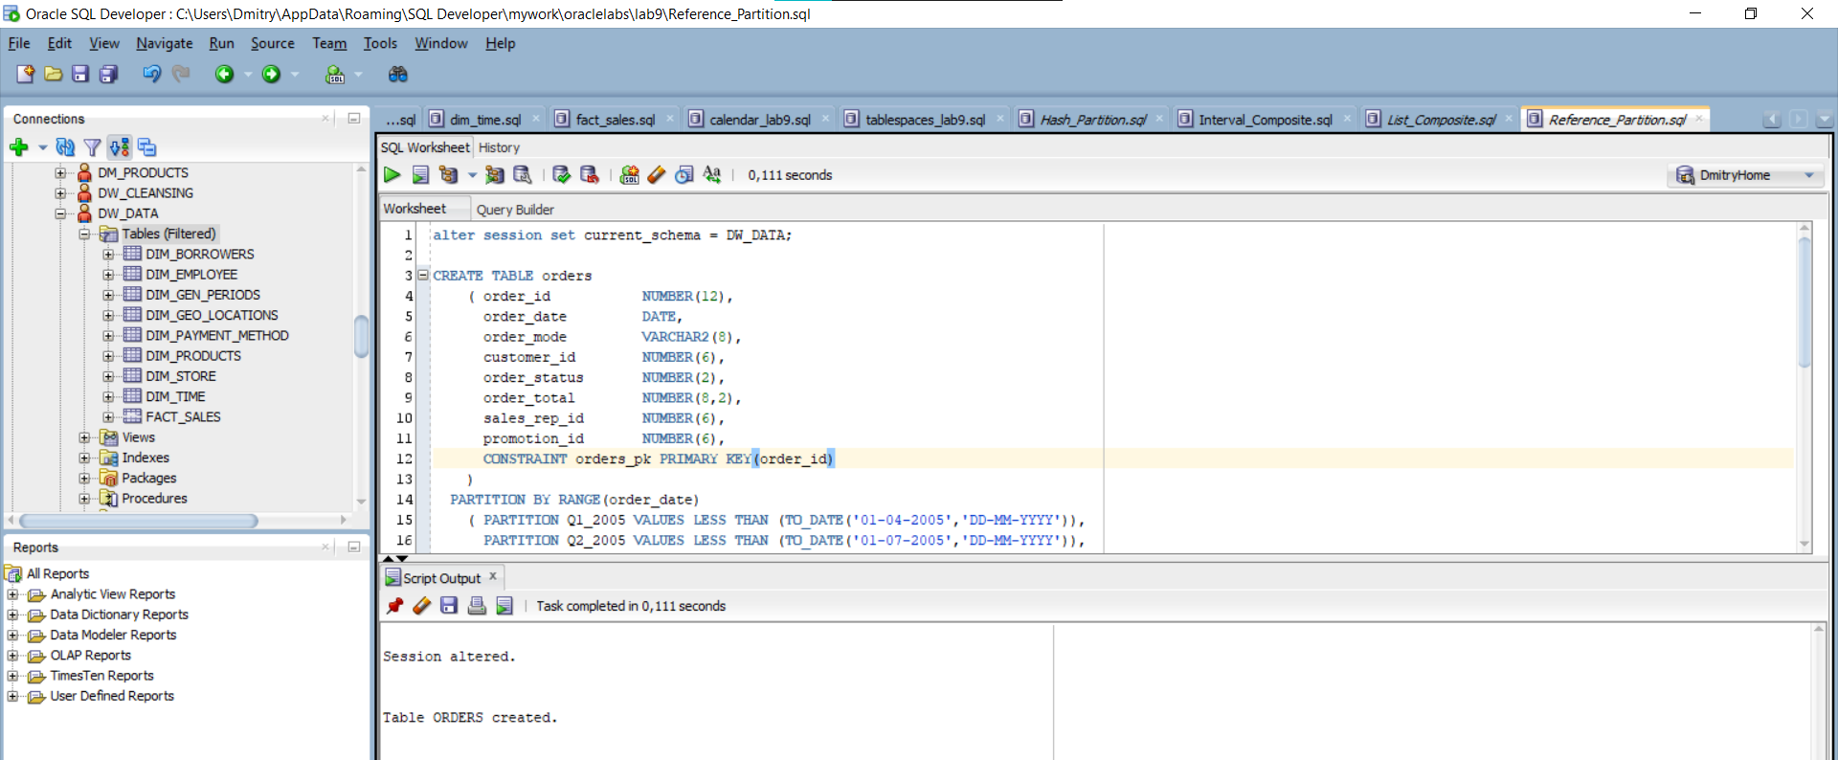

Picture 20 - Creating Partition

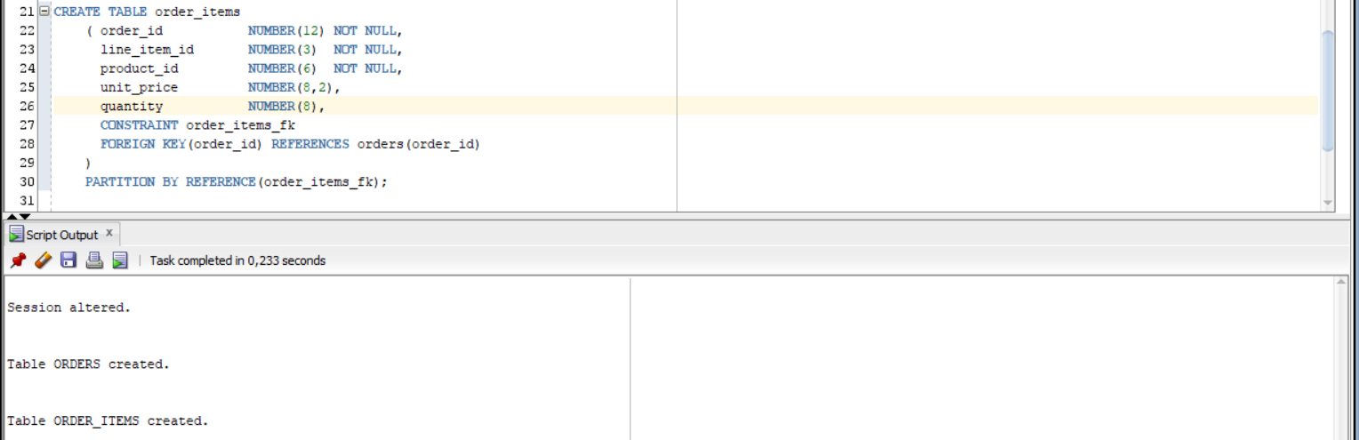

Picture 21 - Creating Referencing Table

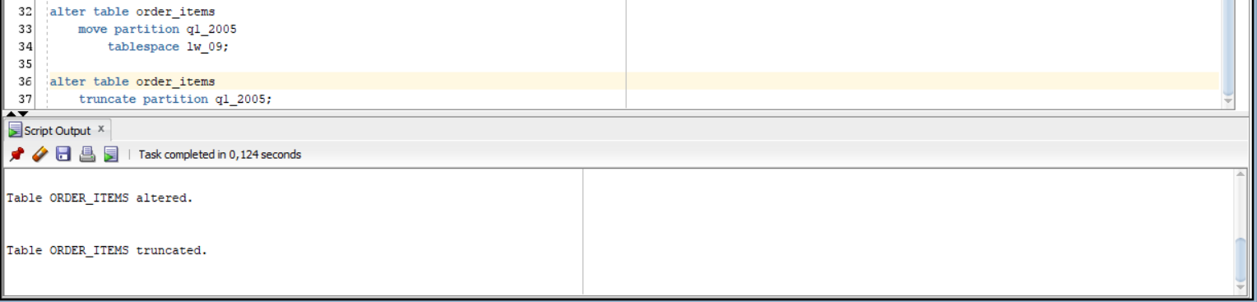

Picture 22 - Moving and Truncating Partition

# 3. Business Task - Partitioning Facts

## 3.1. Partitioning Facts

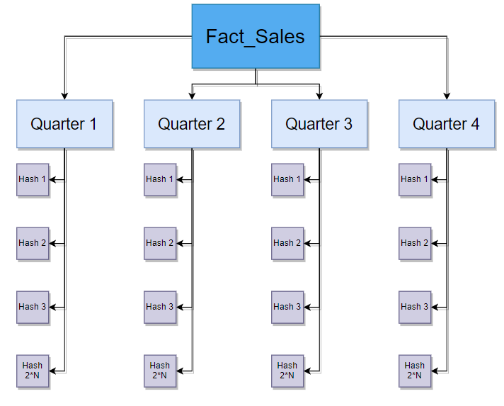

Picture 23 - Partitioning Fact Table

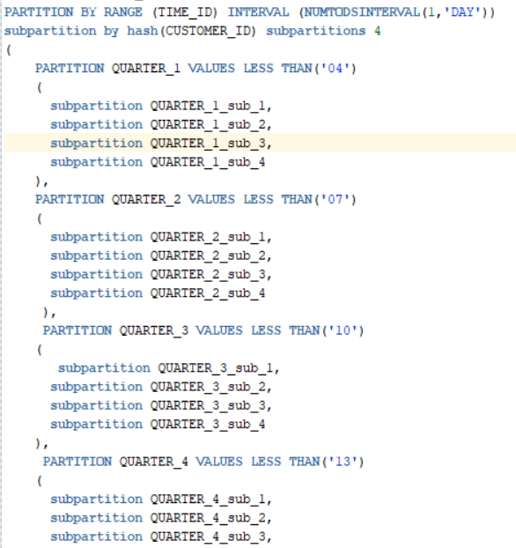

Picture 24 - Example Partitioning Fact Table

**Laboratory work summary:**

We can **improve** **query performance** using partitioning by Quarters**.** We need to divide partitions into sub – partitions (4 cause of amount of s – p needed to be in a degree of 2).

We touched principals of Partitions creation. We use several of them to practice. Also described some benefits of using range and hash partitioning e.g. for our business task. All diagrams and scripts are stored in GitHub (link in README file in Labs folder)